**Workings in python program on Linux OS:**

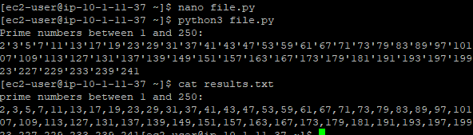

**Python program in Nano editor:**

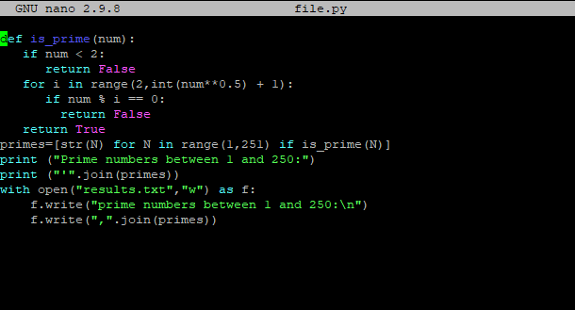

**DEVOPS TOOLS AND ONELINERS:**

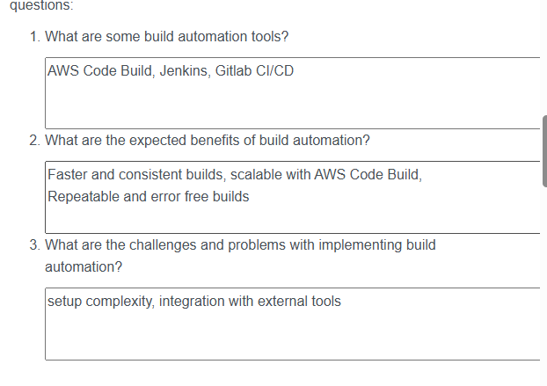

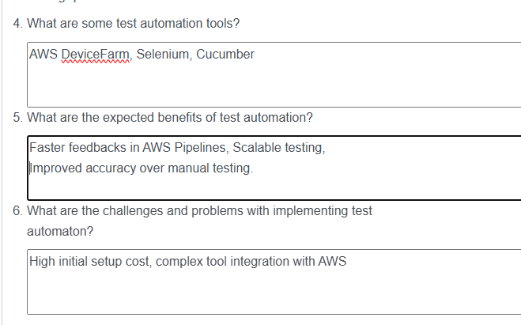

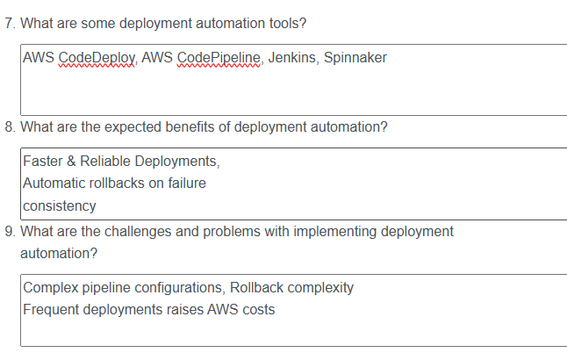

|  |  |  |
| --- | --- | --- |
| **AUTOMATION** | **ORCHESTRATION** | **BOTH** |
| **PYTHON SCRIPT** | **MANAGEMENT** | **PROVISIONING** |
| **CODE** | **DECREASE FRICTION AMONG TEAMS** | **INFRASTRUCTURE** |
| **SINGLE TASK** | **WORKFLOW** | **INCREASE RELIABILITY** |
| **PROCESS COORDINATION** |  | **TERRAFORM** |
| **HCL** |  | **DECREASE IT COST** |
| **CONFIGURATION LANGUAGE** |  | **INCREASE PRODUCTIVITY** |
| **ELIMINATE REPETITION** |  |  |
| **USER DEFINED FUNCTION** |  |  |
| **VERSION CONTROL** |  |  |
| **UNIT TEST** |  |  |
| **THREAD CREATION** |  |  |
| **PYCHARM** |  |  |